Beer Keg Monitoring System
Build your own beer keg monitoring system that keeps track of how many glasses of beer are left in each keg. The entire system costs less than $100 for 5 beer taps.

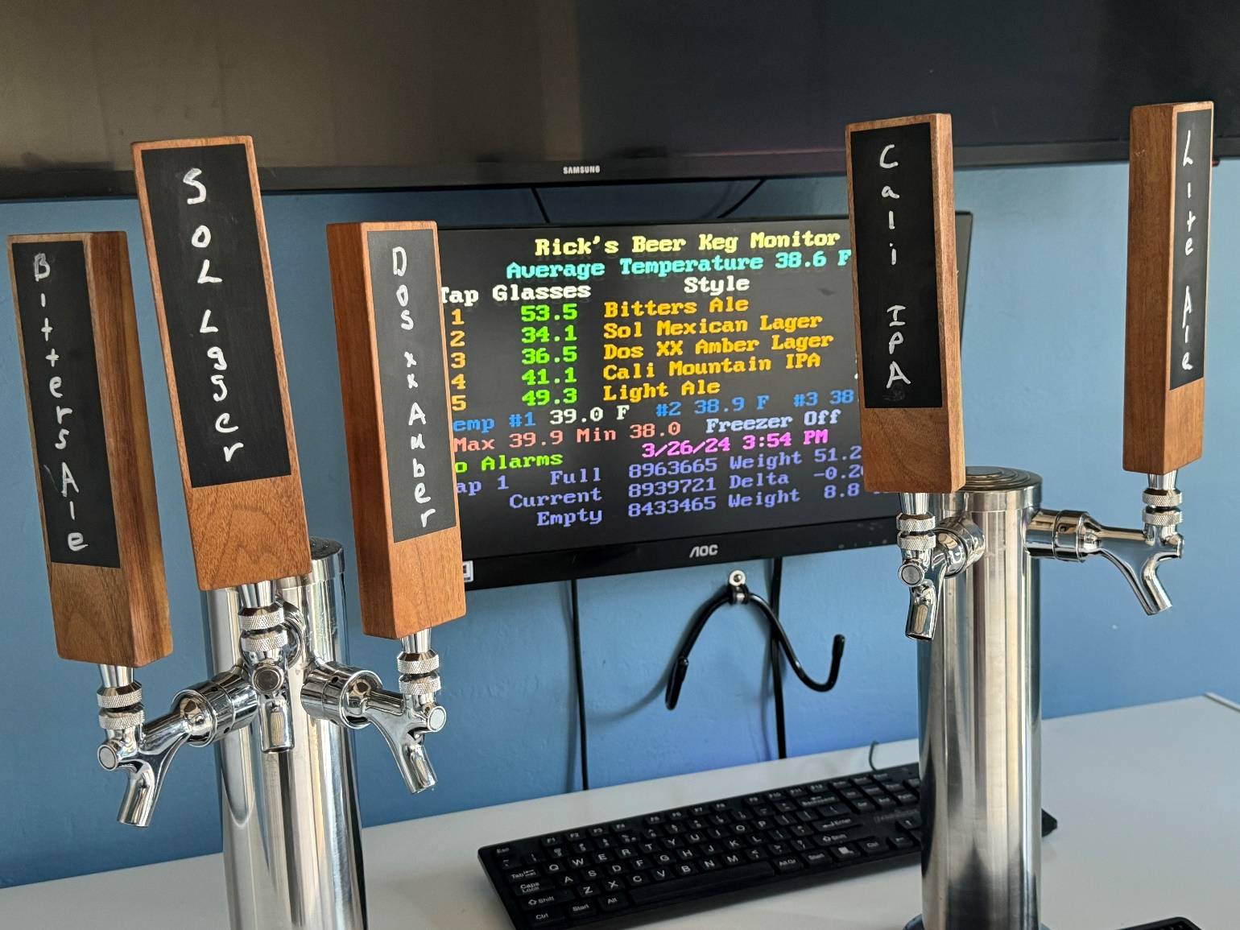

Features:
- Tracks number of glasses of beer left.
- Controls Beer freezer temperature
- Provides email and text message notifications.
- Provides local and remote displays via Wi-Fi.
  - Accessible anywhere in the world with Port Forwarding
- Monitors up to 5 beer taps.
- Temperature Stability +/- 0.75 degrees F
- Works with all DHT and/or MCP9808 Temperature Sensors
  - Up to 3 temperature sensors can be used.

Introduction
Currently there are two types of systems to measure how much beer is left in the keg:
- Flow measuring.
- Weight of Keg.
Flow measuring systems are cheaper (6 taps about $500) but they have limited utility and you have to clean them every time you clean your beer lines (every 6 weeks).
Weight of keg systems are none intrusive, but very expensive ($1000 for 5 taps). They are not integrated with your entire system. This system measures the weight of the keg but is low cost.

Bill of Materials
The following is the bill of Materials for the entire system:
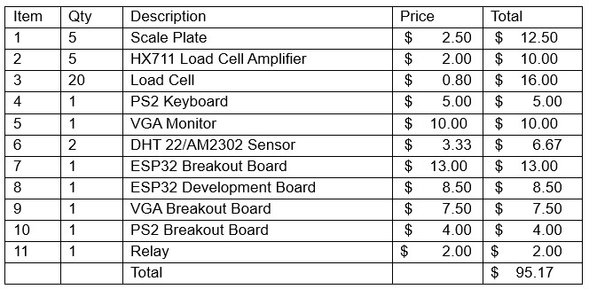

Tools Required
- Soldering Iron (Amazon $10, Soldering Iron Kit - 9-in-1 With 5 Tips, Solder Wire)
- Connectors and Crimping Tool (Amazon $30, Kit with 1550PCS Male and Female 2.54mm Terminals)
- Multi Meter (Recommended Harbor Freight $7, 7-Function Digital Multimeter)
- Drill Motor
- Small Pliers, screw drivers
The following figure is a high level over of the whole project:
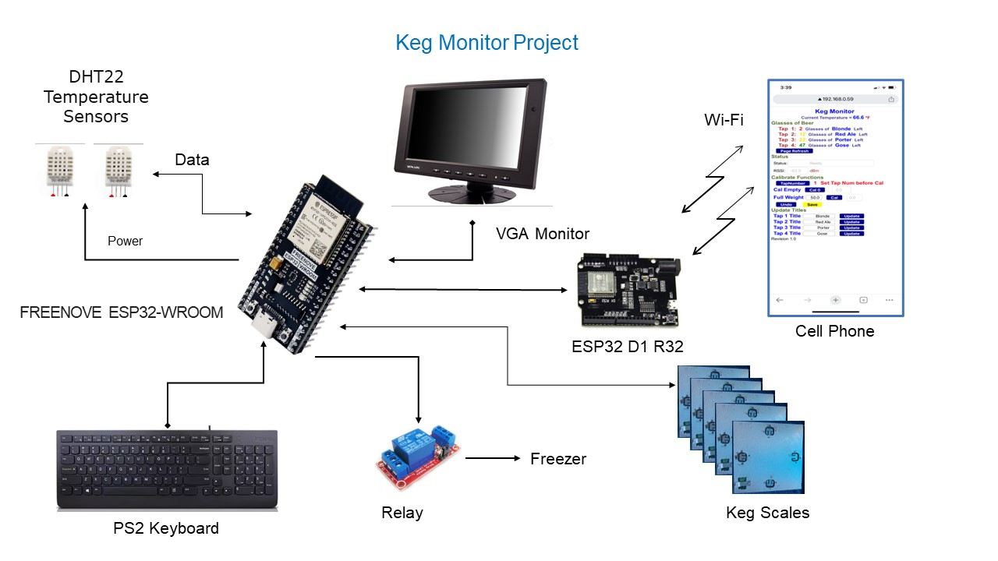
The above block diagram shows the entire system.
If your beer storage unit already has temperature control, you will not need the temperature sensors or relay. If you only want a local display, you can eliminate the ESP32 D1 R32 board and the interface wire.
My beer freezer is in the pool shack which does not have Wi-Fi. To get Wi-Fi, I installed an old ESP32 board under the eave and ran a cable between the two processors. They talk to each other on a serial interface.

Theory of Operation
The theory of operation is quite simple. The data you need is:
- Scale reading with nothing on the scale (Empty Scale Quanta)
- Scale reading with a full keg of beer on the scale (Full Scale Quanta)
- Scale reading of current keg (Current Scale Quanta)
- Weight of a full keg (Full Keg Weight)
- Weight of an empty keg (Empty Keg Weight)
The system automatically measures the first three items, all you need to do is measure the full key weight and the empty keg weight. I just use a bathroom scale.
Reading Per Ounce = (Full Scale Quanta – Empty Scale Quanta) / (Full Keg Weight * 16)
Current Ounces = (Current Scale Quanta – Empty Scale Quanta) / Reading Per Ounce
Glasses = (Current Ounces – Empty Keg Weight) / 12 Ounces per glass

Software
The software is described in the software folder. There are two subfolders for the software, one for the main Keg Monitor and the other for the Wi-Fi display.

Hardware

VGA Monitor
For this project I selected a VGA monitor for my local display. VGA monitors are large and easy to read for my guests. They are also readily available and cheap. I got mine free at a garage sale. They were closing and the monitor was still there, so they gave it to me. I also bought a VGA monitor at a thrift store for 10 dollars. The monitor came with a power cord and VGA cable.

VGA Adapter
You need a VGA adapter to connect the VGA cable to your processor board. I used a VGA Female 3 Row 15Pin Connector Breakout adapter shown on the right. Available from Amazon.

Keyboard
I selected a PS2 keyboard for this project because they are very easy to interface. You can normally find PS2 keyboards at garage sales and thrift stores, but they are getting harder to find. You can tell it is a PS2 keyboard by the distinctive round PS2 connector. For a while they made PS2 compatible keyboards with a USB connector, but unless the keyboard specifically says PS2 compatible it will not work. If you can't find a used PS2 keyboard, new ones are available on Amazon for about 20 dollars.
The PS2 keyboard requires 5 volts to operate and the ESP32 operates on 3.3 volts. So, you need to make sure that the keyboard is wired to 5 volts and the pullup resisters are connected to the 3.3-volt supply. The PS2 output is an open collector interface.
PS2 breakout adapters like the one shown are available but can be hard to find. There are USB to PS2 adapters readily available, so you can use a USB breakout adapter instead.

Freezer Control Relay
The Freezer Control Relay is used to turn On/Off the freezer. If you are using a refrigerator or already have a freezer controller you do not need this relay.
The relay switch is 250VAC and 10A load with an Optocoupler Isolator: 3.3V power relay module. The freezer I use was an Insignia™ - 10.2 Cu. Ft. Chest Freezer. The startup current is 21.4 amps and the on current is 2.0 amps. The relay has handled the startup current fine. I installed the relay in a standard electrical box as shown in the following figure.
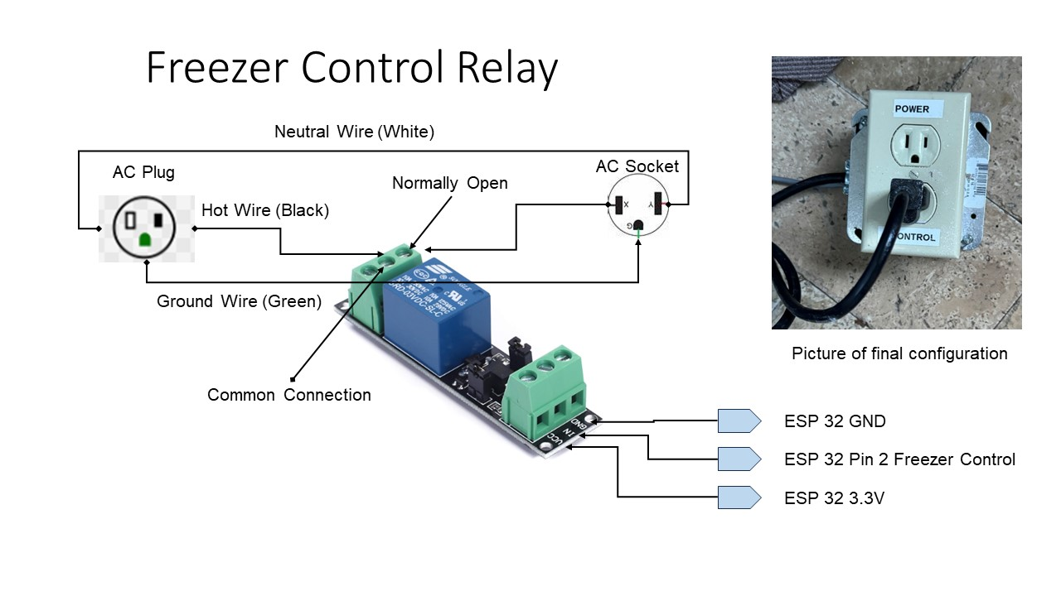

Processor Board
For this project I selected the FREENOVE ESP32-WROOM development board. The main reason is the breakout board that is available for this board. The breakout board is great. I prefer to use an Arduino power supply connector instead a type C USB connector. The parts are shown in the following figure. I also used a distribution board for all the power and ground connections.

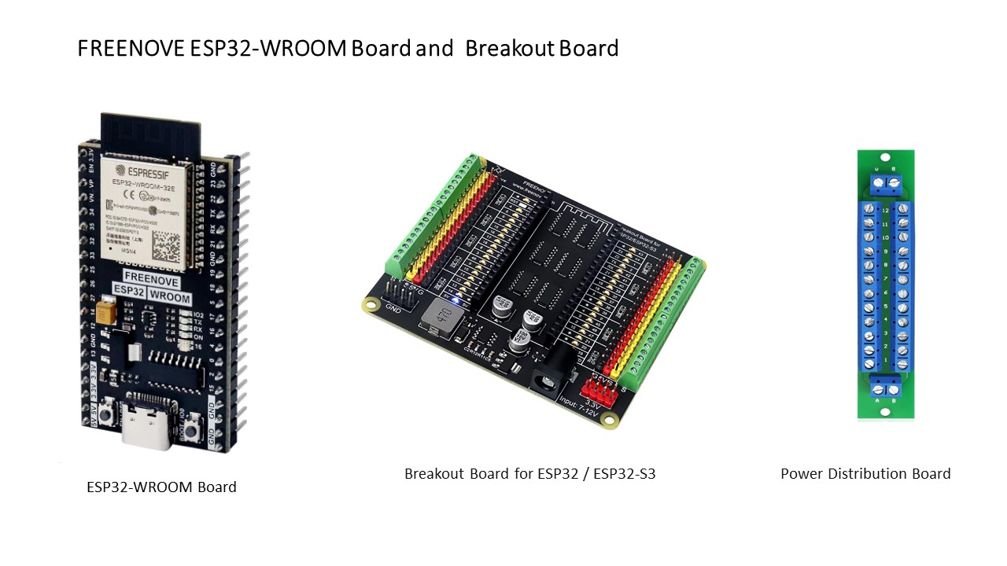

Scales
For the scale plate I used Aluminum Composite Sign Panel sheet. The sheets are 1/8 inch thick and come in a variety of sizes. The most common is 12 inches by 24 inches. You can use standard wood cutting tools to work with the plates.
I made two sizes of scale plates. 9.25 inches for Corny and 1/6 Barrel kegs. 12.125 for the Slim 1/4 Barrel.

Making the Scales
I used two different methods to make the scales. The figures show the two different methods. For the first one I used a table router and a table saw. The holes are for the strain gauge and on the center line of the plate. I made them through holes so you can align the strain gauge in the slot. I routed an area is for the HX711 board. You route out the area leaving a 1/16 inch top. You cut a through area for the pins to go through the board.
With the scrap aluminum plate, I made some retainers to hold the the strain gauge retainer in place. For the retainers, you route out an area and again leave 1/16 inch top material. The retainer only keeps the strain gauge from moving. All the keg weight is supported by the plate and the strain gauge. I also made a little retainer to hole the HX711 board in place.
To hold the retainers in place I used 1/4-inch flat head machine screws. I drilled and tapped the plate to hold the screws. You can also use sheet metal screws, so you don't have to drill and tap.
If you don't have a router table you can cut the holes in the plate and use sheet metal screws to hold the strain gauges and HX711 board in place.

Keg Holder
I made keg holders for the kegs. It is important to use these to protect the HX711 connector from getting squashed and provide a hard surface for the strain gauge to sit on. My freezer bottom was soft and strain gauge pressure point went right into the bottom. The keg holder uses 1x2 lumber for the frame with a hard plate on the bottom. I used vinyl plank flooring on the bottom. It is completely waterproof, has a nice rubber backing for the bottom and has a very hard surface. The bottom is just nailed to the frame.

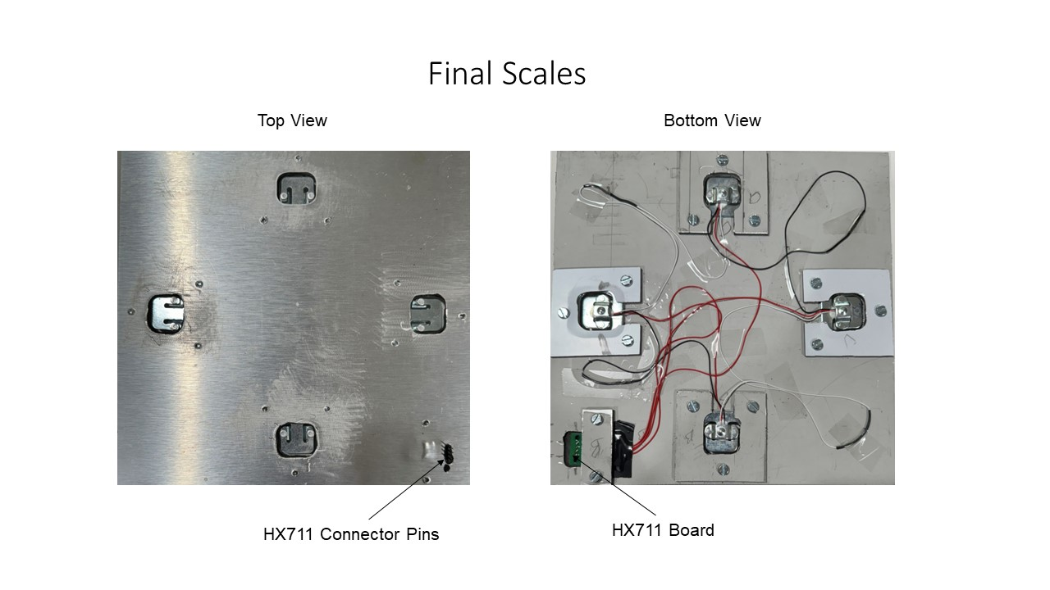

Check out the hardware folders for all the intimate hardware details.

Why a Keezer?
A Keezer is a chest Freezer converted to a Kegerator which is commonly called a Keezer.
A Keezer has many advantages:
- They are more energy efficient.
- They have a lot of space for the cost.
- It is easy to access all the keg connectors.
- It is easy to install and remove the kegs.
Most freezers are not tall enough for the kegs with the fittings, so you need to install a frame (collar) between the freezer top and the freezer base. This is not very hard. You can find lots of articles on the internet that describe how to do this.
The advantage of the collar is you do not have to drill through the wall of the freezer to install taps, risking hitting a freezer coil. You can also drill through the collar to bring in and out wires.
You should insulate the kegs from the bottom of the freezer to prevent the beer from freezing and protect the bottom of the freezer. I used padded vinyl plank flooring which worked great.

Lessons Learned
- Buy solid wire instead of stranded. Much easier to work with.
- Use an Ohm meter to check everything out. It can save a lot of troubleshooting time. You can get one at Harbor Freight for just a few dollars.
- Buy the ESP32 Development Boards, instead of the UNO form factor boards (i.e. ESP32 D1 R32 or ESP8266 D1 R2). Much easier to work with, better Wi-Fi, and faster.
- If you need a lot of memory and pins use the ESP32-S3 development boards.
- Use breakout boards with screw terminals, much easier and more reliable than the solder boards.

Temperature Sensors
I initially started with DHT22 temperature sensors. I found that these sensors hung up and would not be responsive. To keep the sensors working I ran power to each sensor from a GPIO pin. When the sensor stopped working, I turned the power on and off to reset the sensor. This change solved the problem. I think the source of the problem may be a power surge when the freezer turns on and off. I have used these sensors in the past without any problems.
I decided to try MCP9808 sensors. These sensors are more accurate and work on the I2C bus. These sensors worked better in my environment. The temperature values are more stable and consistent. I modified the software to work with both DHT and MCP sensors. My final configuration is two MCP sensors and one DHT sensor. I felt that even if the I2C bus goes down I would still have one working temperature sensor.
I also installed a little fan in the freezer. I got much more consistent temperature readings with the fan moving the air inside the freezer.
You can read about the temperature sensors in the hardware folder.

